What CSS properties are required to create storyboard layouts

Examine the storyboard below.

List the different sections on the page (e.g., heading).

List the design principles being used.

Write down the HTML elements you would use to create the content structure.

Write down CSS properties that could be used to style the HTML elements you have identified.

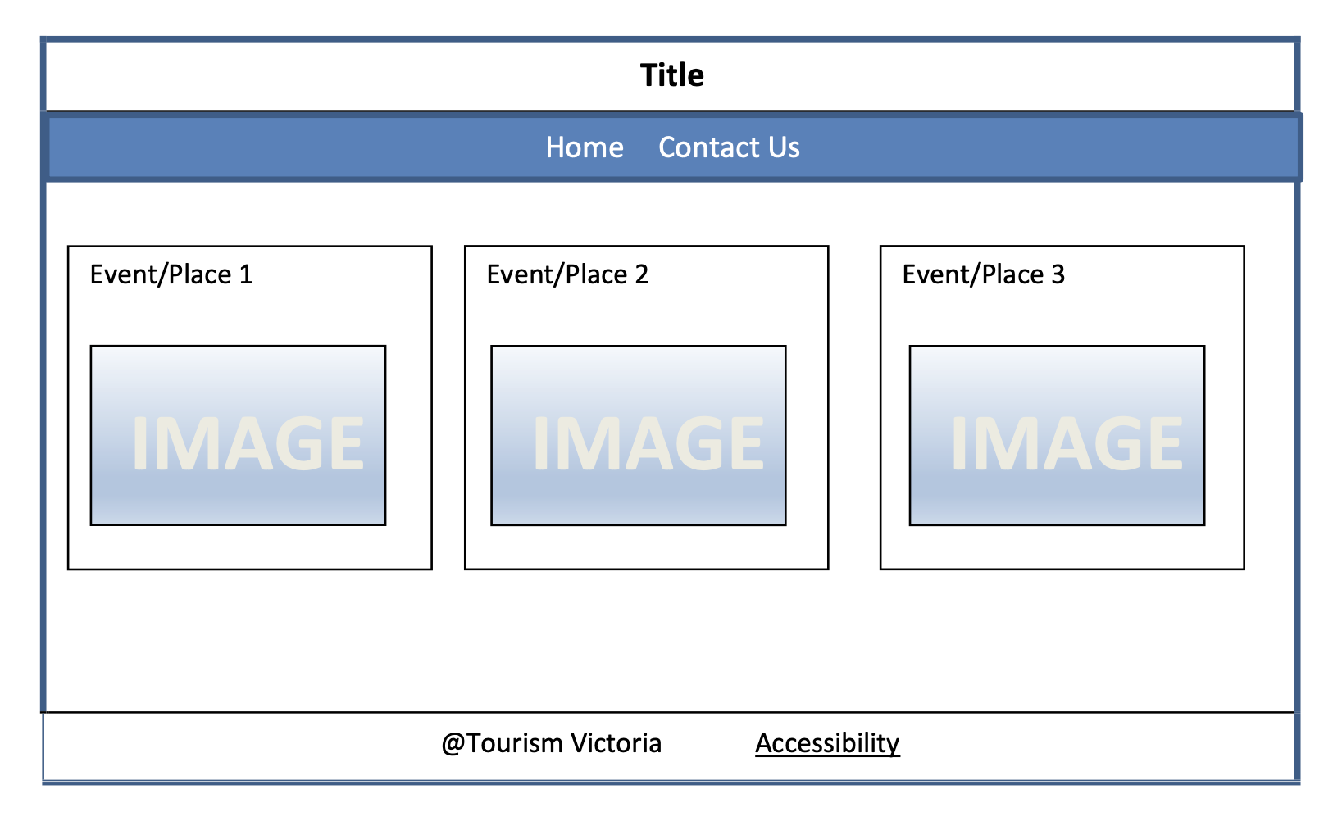

Start implementing the selected storyboard into your project (AT1)